PROJECT REPORT TEMPLATE

CRM APPLICATION THAT HELPS TO BOOK A VISA SLOT

1 OVERVIEW

* 1. Introduction:

The Title project allotted to our group is **CRM APPLICATION THAT HELPS TO BOOK A VISA SLOT.**

A visa slot management project is a system that is used to track and manage the availability of visa slot,which are appointments that are required for certain visa applications.

1.2 PURPOSE

CRM based application has variety of applications and particularly it is used by a government agency or a visa processing centre to schedule and manage appointments with applicants.

2 PROBLEM DEFINING AND DESIGN THINKING:

2.1 EMPATHY MAP:

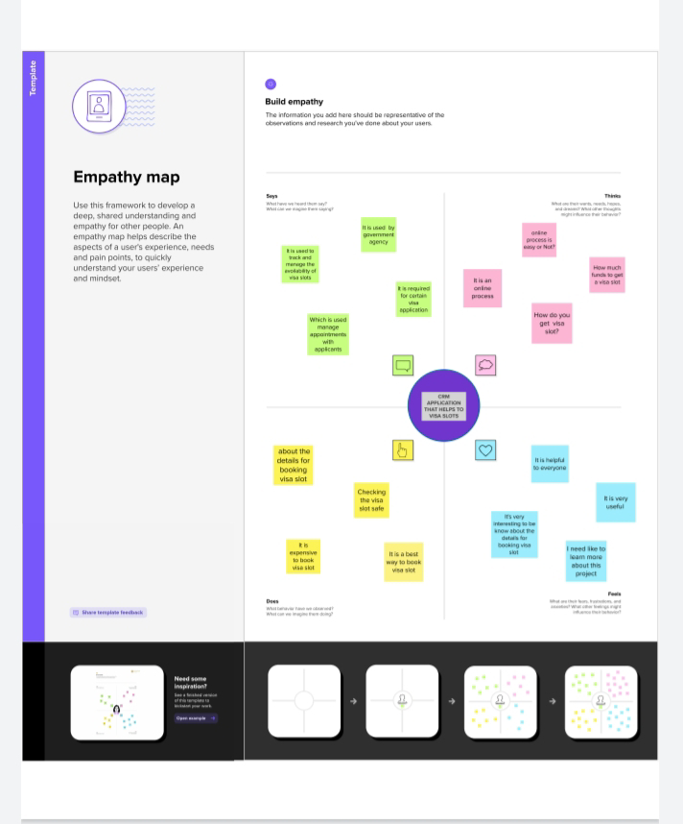

2.2 Ideation and Brainstorming map:

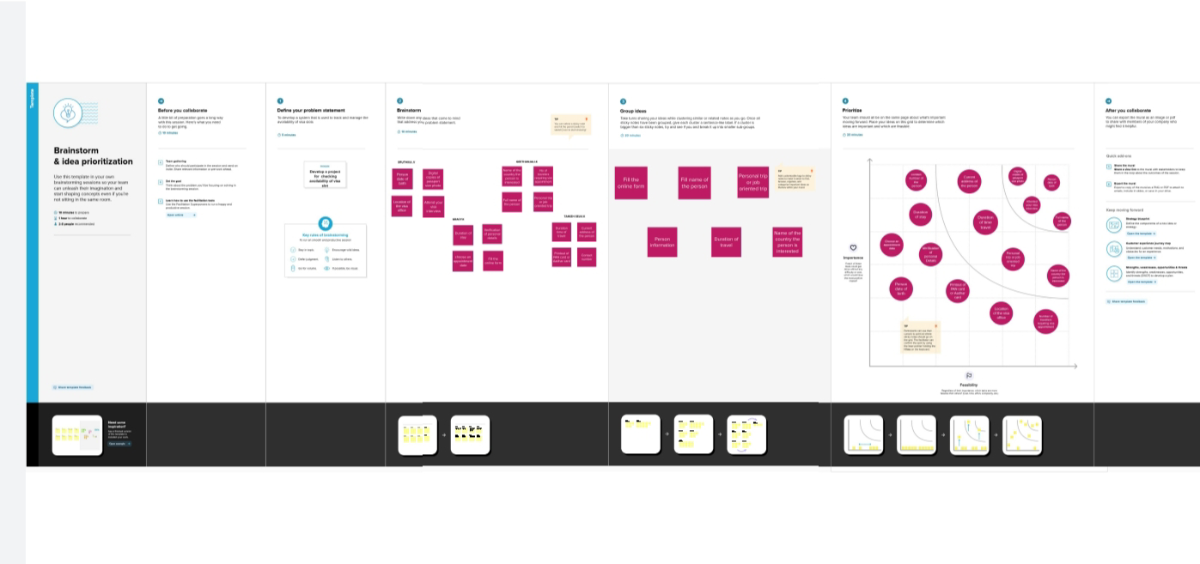

3 RESULT

3.1 Data Model:

|  |  |  |  |  |
| --- | --- | --- | --- | --- |
| Object | Passport | Visa slot | Payment | Reschedule/cancel |
| Fields | Full name | Location | Payment mode | Passport Number |
| Fields | Passport Number | Time | Card number | Location |
| Fields | Contact number | Passport  Number  (master) | Transaction ID(auto number) | Time |
| Fields | Permanent  address | Visa slot | Cancel Transaction | Cancel |
| Fields |  |  | Visa slot number | Status |

3.2 ACTIVITY AND SCREENSHOT:

REPORT1:

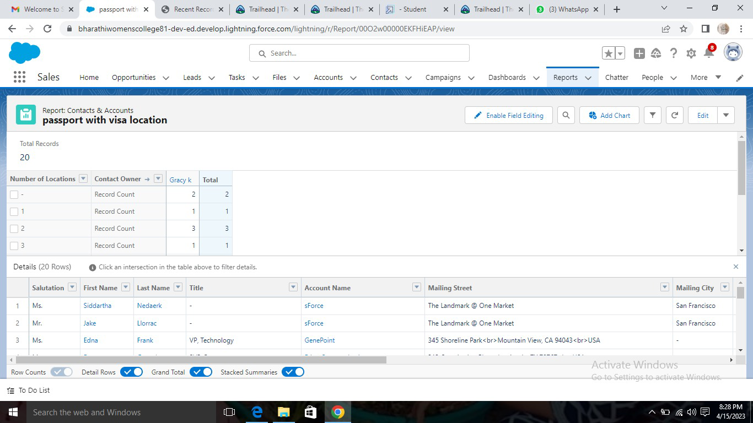

REPORT 2:

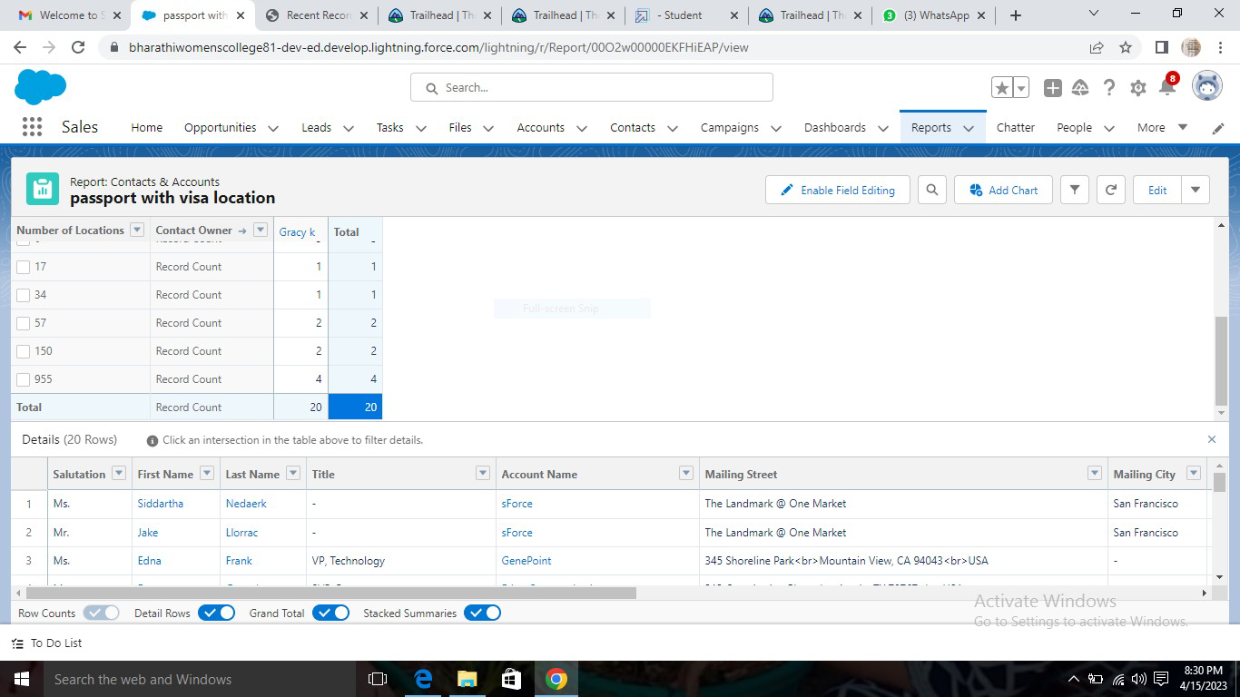

ACTIVITY 1: Creation of custom object:Passport

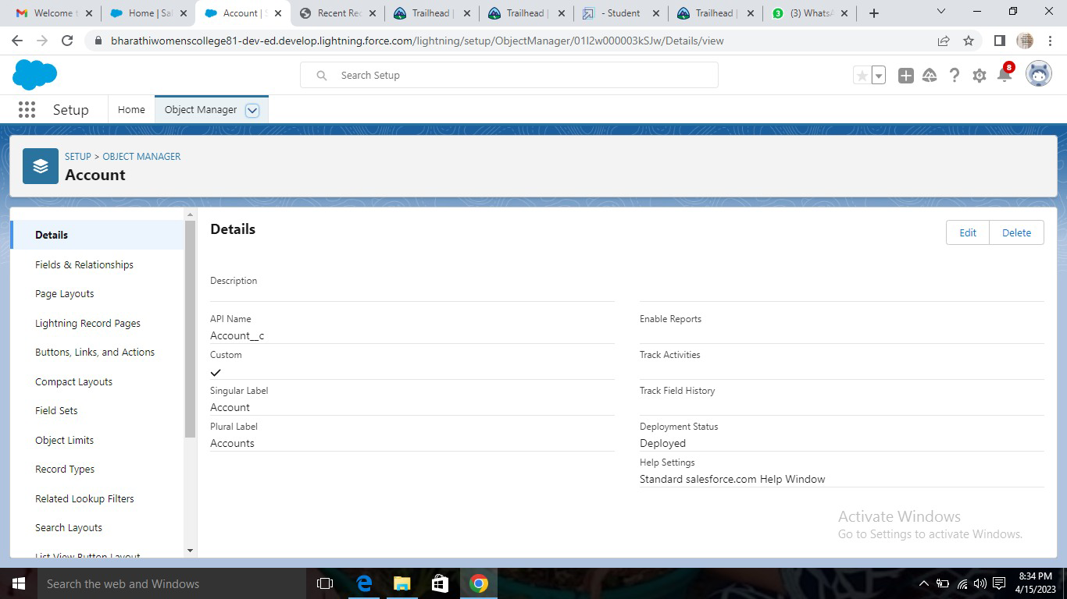

You will navigate to custom object definition edit where you have give the object name.

ACTIVITY 2: Creation of fields on custom object:Passport

Select your object from object selection has passport



And selection the option fields and relationships.

MILESTONE 1

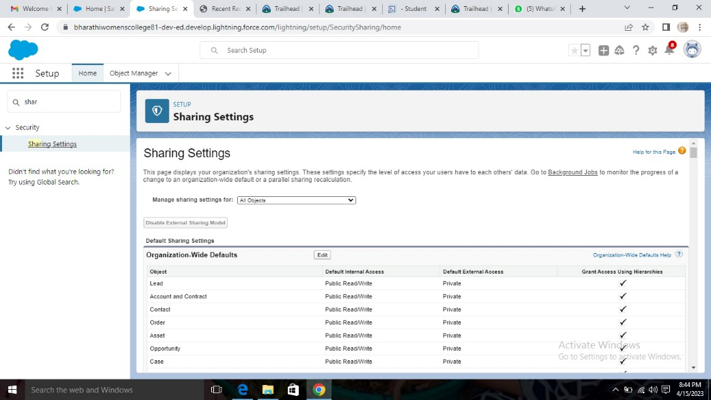

OWD: Organization wide default settings.

MILESTONE 2: Creation of app

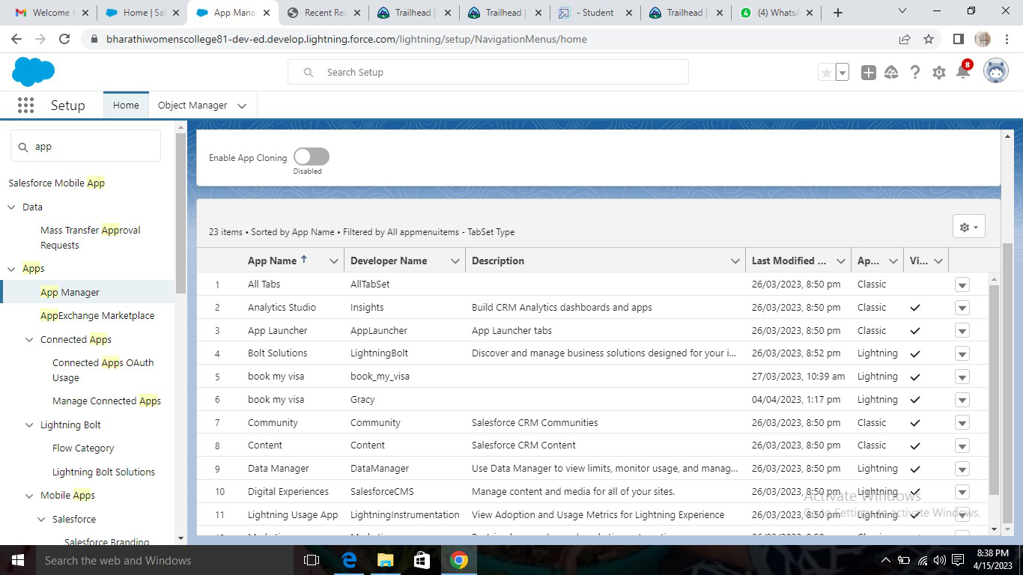

MILESTONE 3: USERS

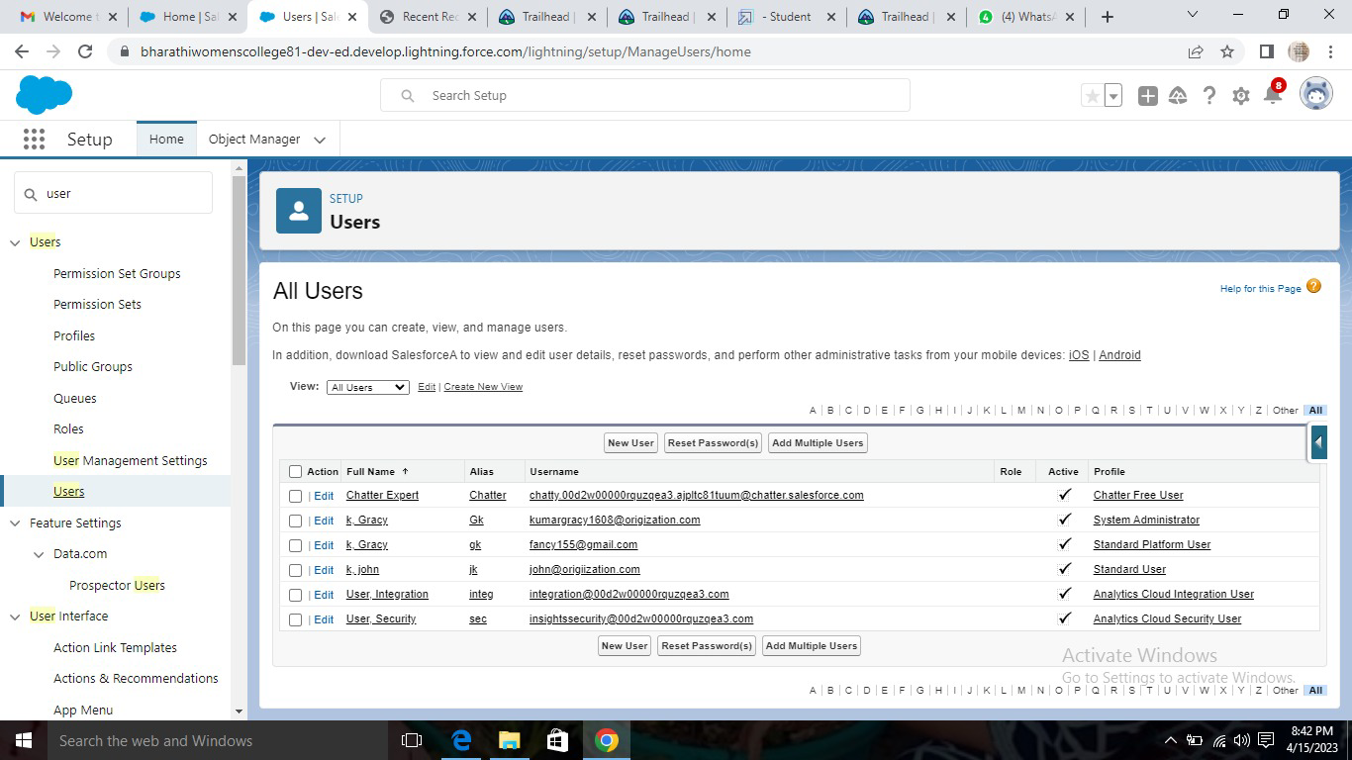

MILESTONE 4 :Creation of Dashboard option

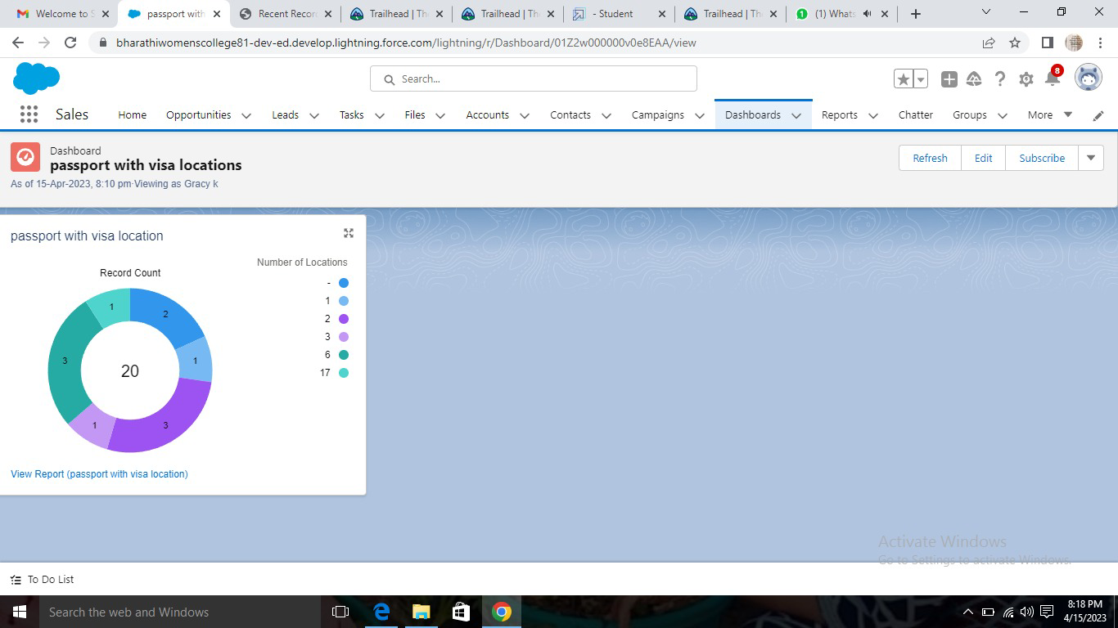

4 Trailhead profile public URL

TEAM LEADER: <https://trailblazer.me/id/psruthikav>

TEAM MEMBER 1: <https://trailblazer.me/id/grack5>

TEAM MEMBER 2:<https://trailblazer.me/id/ptamizhselvik>

TEAM MEMBER 3:<https://trailblazer.me/id/pgeethanjalik>

5 ADVANTAGES&DISADVANTAGES

|  |  |
| --- | --- |
| ADVANTAGES | DISADVANTAGES |
| Passport is a format government issued ID | Shorter initial Stay |
| Some visa give you more freedom than others. | Labour condition Application requirement |
| To qualify for a visa passport is actually needed | Traveller purpose id not permitted on visitor visa |

6 APPLICATION:

* Ordinary passport is issued to ordinary citizens for private travel,such as for vacation,study and business trips.
* Official passport is issued to individual representing the government of india on official business.
* Diplomatic passport is issued to indian diplomats,member of parliaments,member of the union council of ministers.

7 CONCULSION:

A visa slot management project is a system that is used to track and manage the availabilyu of visa slots,which are appointments that are required for certain visa processing centre to schedule and manage appointments with applicants.

8 FUTURE SCOPE:

The method for submitting an application for a fresh passport will remain the same, as will travel insurance. The ministry of external affairs plans to provide electronic passports to all 36 indian passport offices. The issusing method will remain unchanged. OVER 120 countries,including the united kingdom,the united ststes,and Germany,have previously accepted the e-passport model,which includes the biometric e-passport infrastructure.

The indroduction of e-passports with integrated chips is a positive step for the indian travel and tourism sector since it will make international travel easier,allowing more individuals to travel abord.The move will also enhance security,fisrt and foremost,because it would be difficult for criminals to forget or steal an e-passport.